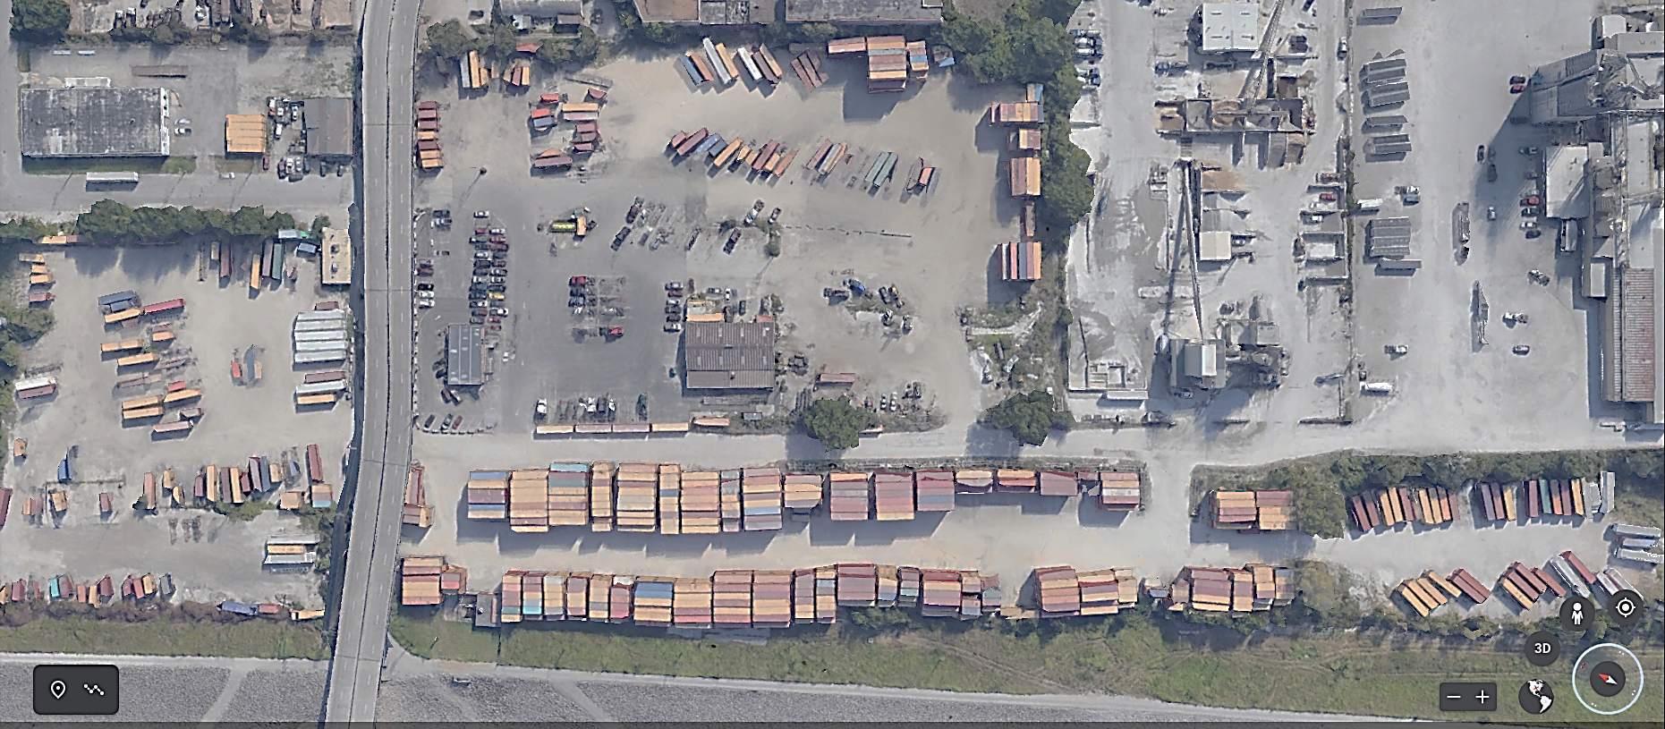

* All yard equipment has the right of way
* Be curteous to one another



***The IXT yard rules are important to follow at all times***

* Do not enter the pink shaded area unless you have checked in. NO CIVILIAN VEHICLES IN THIS AREA.
* Flashers on at all times
* 5 MPH
* Must stop in office on outgate exit – sign interchange

**EXIT**

**CHECK IN HERE**

**ENTER**

**WHEN ARRIVING TO IXT CENTRAL FOLLOW BELOW MAP**

***YOU MUST ALWAYS STOP AT THE CHECK- IN OFFICE WHEN PICKING UP/DROPPING EQUIPMENT***